GeoCoding_LeadingZeros fix

Tool Overview:
This document provides the broad approach of process identified for fixing/moving the service location features to new location with reference to the Re-Geocoding process which was affected by leading zero’s present in the street names of core logic parcel data.
This process only applicable for the service point/service location records that are having null APNNUM values in GIS data and are assigned with the APNNUM values in Re-Geocoding process.
Input Table preparation:
- GEOCODING_RESULT – Re geocoded result table after cleanup of leading zeros in parcel data and then updated with APNNUM. Import the table from provided gdb file.
- UPD_REGEOCODING_RESULT – Table created using the selection query using EDGIS.SERVICEPOINT and DATACONV.GEOCODING_RESULT tables where EDGIS.SERVICEPOINT.APNNUM is null and DATACONV.GEOCODING_RESULT is not null.
CREATE TABLE UPD_REGEOCODING_RESULT
(
OBJECTID INTEGER,
SERVICELOCATIONCONVID NUMBER(38,8),
SERVICEPOINTCONVID NUMBER(38,8),
TRANS_CEDSAID NUMBER(38,8),
TRANS_CGC12 NUMBER(38,8),
GIS_STREETNUMBER NVARCHAR2(24),
GIS_STREETNAME NVARCHAR2(128),
CEDSA_STREETNUMBER NVARCHAR2(200),
CEDSA_STREETNAME NVARCHAR2(200),
GIS_APNUM NVARCHAR2(60),
NEW_APNNUM NVARCHAR2(200),
NEW_XCORD NUMBER(38,8),
NEW_YCORD NUMBER(38,8),
SERVICELOCATION_OBJECTID NUMBER(38,8),
SERVICELOCATION_GLOBALID NVARCHAR2(255));
Insert into UPD_REGEOCODING_RESULT
(OBJECTID,SERVICELOCATIONCONVID,SERVICEPOINTCONVID,TRANS_CEDSAID,TRANS_CGC12,GIS_STREETNUMBER,GIS_STREETNAME,CEDSA_STREETNUMBER,CEDSA_STREETNAME,GIS_APNUM,NEW_APNNUM,NEW_XCORD,NEW_YCORD,SERVICELOCATION_OBJECTID,SERVICELOCATION_GLOBALID)
select rownum,a.conversionid,b.conversionid,c.TransformerID,c.cgc12,B.STREETNUMBER,B.MAILSTREETNAME1,C.STREETNUMBER,C.STREETNAME1,B.APNNUM,C.APNNUM, C.X ,C.Y,a.objectid, A.GLOBALID from EDGIS.servicelocation a,EDGIS.servicepoint b,DATACONV.GEOCODING_RESULT c
where A.GLOBALID = B.SERVICELOCATIONGUID and B.SERVICEPOINTID = C.SERVICEPOINTID and B.APNNUM is null and C.APNNUM is not null;

CREATE TABLE UPD_REGEO_SERVPTREL
(
OBJECTID INTEGER,
SERVICELOCATIONCONVID NUMBER(38,8),
SERVICEPT_COUNT NUMBER(38,8),
SERVICELOCATION_OBJECTID NUMBER(38,8) ,
SERVICELOCATION_GLOBALID NVARCHAR2(255),
TRANS_CEDSAID NUMBER(38,8));

insert into UPD_REGEO_SERVPTREL (SERVICELOCATIONCONVID,SERVICEPT_COUNT,SERVICELOCATION_OBJECTID,SERVICELOCATION_GLOBALID,TRANS_CEDSAID)select SERVICELOCATIONCONVID,count(SERVICELOCATIONCONVID),SERVICELOCATION_OBJECTID,SERVICELOCATION_GLOBALID,TRANS_CEDSAID from UPD_REGEOCODING_RESULT
GROUP BY SERVICELOCATIONCONVID,SERVICELOCATION_OBJECTID,servicelocation_globalid,TRANS_CEDSAID;

Tool Functionality:
Tool will iterate through the records of “UPD_REGEO_SERVPTREL” table. For Module 1_1 tool will divide rows from UPD_REGEO_SERVPTREL table into parts (5000 each). So, we can run tool multiple times based on objected range from whereClause Combo box selection. For each run it will take approximately 2 to 3 hours.
Module 1_1
Condition: Tool will query the GDB data of service point records if one location feature related to one service point record based on combo box(where clause)
- If a service location feature was identified for a GDB service point, and GDB XY location and GIS location is NOT matched, then the service location feature will be relocated
- If a service location feature was identified for a GDB service point, and GDB XY location and GIS location is matched, then the service location feature will NOT relocated-APNNUM field will be updated
- If a service location feature was identified for a GDB service point and GDB XY location and GIS location is NOT matched and if more service points are related to GIS service location then a new service location along with Pseudo service will be created and the existing service point from GIS location will be related to newly created location feature
Module 1_M
Condition: Tool will query the GDB data of service point records if one location feature relates with more service point records
- If all the service point records are existing in GIS location feature and GDB XY location and GIS XY locations are NOT matched, then GIS Service location feature will be relocated to GDB coordinates
- If a GDB service point record is identified in GIS location feature and GDB XY locations and GIS XY locations are NOT matched, then a new Service location feature will be created along with a pseudo service and this Service point record will be related to newly created Location feature
- And if a Location feature was identified in the above case for GDB service point, then only Service point-relationship will be transferred to GIS location feature

1.0) Installation setup
Copy the PGEReGeocodingProcess_setup.msi, setup.exe, PGEReGeoCoding.ini and CentralVally_Corelogic.gdb file to your local system.

Click on the setup file to install the tool (it asks for the path to nstall).
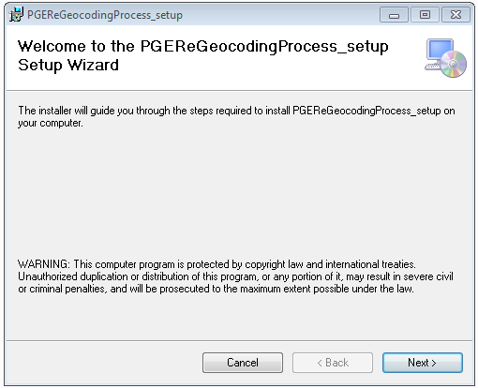

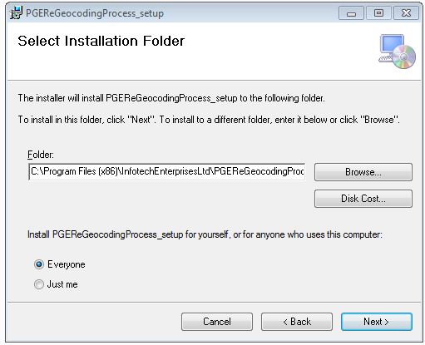
Select the Path to install and depending on user preference select “Everyone /Just me” and click Next button.
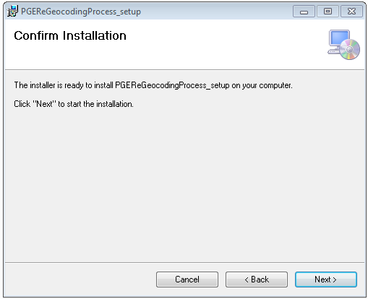
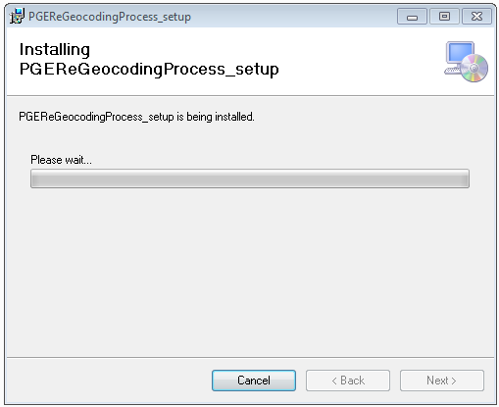
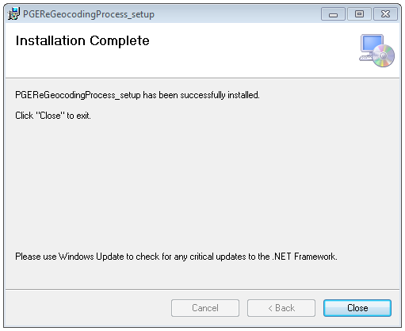
After completion of installation click close button.

Execution Process:
Copy the PGEReGeoCoding.ini and CentralVally_Corelogic.gdb file in same directory.
2) Create a session
2.1) Open ArcMap and connect to the PRODUCTION (EDGIS1P) database and create a session, open the session, save and close the created session.
2.3) Connect to the PRODUCTION (EDGIS1P) databases in ArcCatalog and map to the session created above using the Change button.
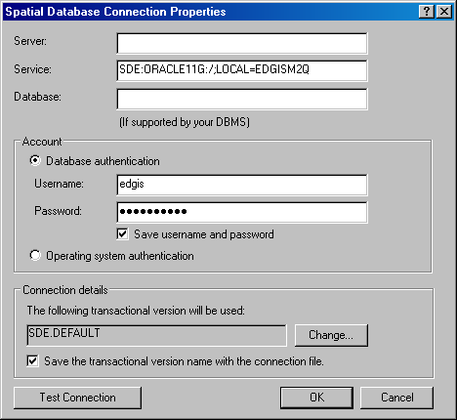

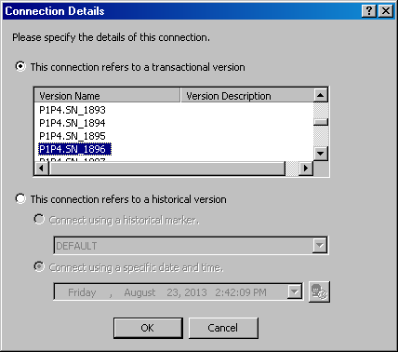

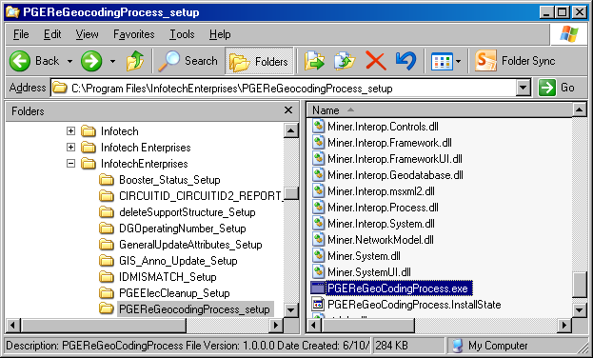
2.4) Click on the PGEReGeoCodingProcess.exe from the installed path and It will open the below interface.
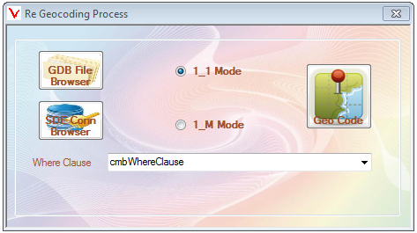
2.5) Click on the browse button and browse the production (EDGIS1P) database sde file from the below path.
**(If tool is to be run on Windows xp - C:\Documents and Settings\p1p4\Application Data\ESRI\Desktop10.0\ArcCatalog\*****.sde)

**(If tool is to be run on Windows7 - C:\Users\p1p4\AppData\Roaming\ESRI\Desktop10.0\ArcCatalog\****.sde)

2.6) By clicking GDB File Browser Button, Browse the directory that contains GDB file and ini file.
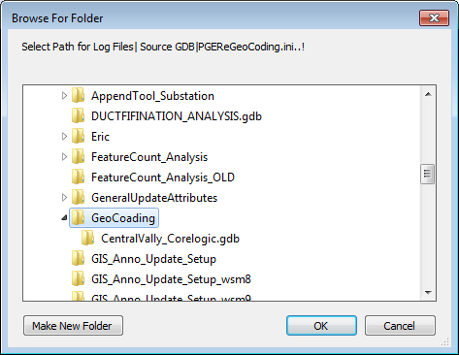

Based on radio button selection, Combo box will enable and disable.
For 1_1 mode, based on feature count in table it will divide into parts and added in to combo box as below.
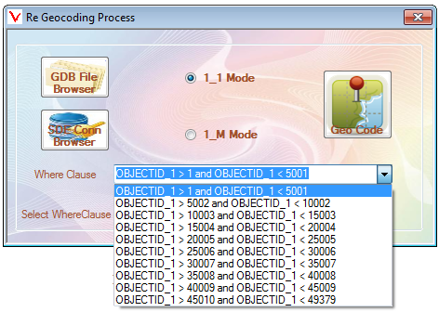

We can run the tool based on combo box selection for selected features.
For 1_M mode combo box will disable and tool will run on all features (not related to Combo box)

2.7) Click ‘Geo code’ button to process the tool on selected features.

2.8) After process completed tool will generate log files in GDB folder.
2.9) Below is the example of tool result:
Before executing the tool:
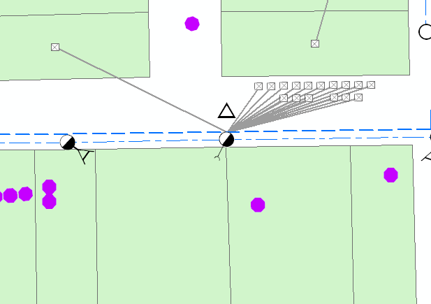
After executing the tool:
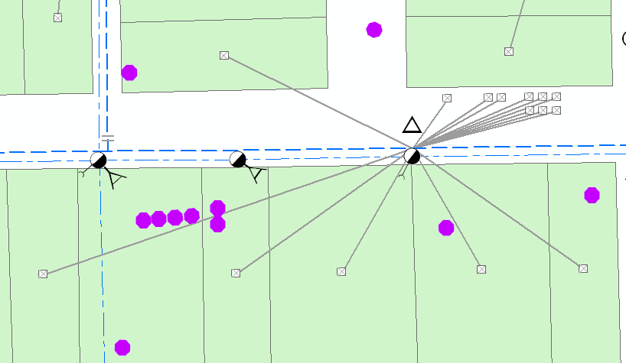

2.10) After completion of the tool execution this session will need to be posted to default upon review of the results.

